**Project Initialization and Planning Phase**

| Date | 13 June 2025 |
| --- | --- |
| Team ID | SWTID1749709635 |
| Project Name | Mental Health Prediction |
| Maximum Marks | 3 Marks |

**Define Problem Statements (Customer Problem Statement Template):**

The current process for seeking mental health support in the workplace presents challenges for employees, impacting their well-being and satisfaction. Employees, especially in tech companies, face obstacles such as uncertainty about available support and fear of stigma. These issues can lead to reluctance in seeking help, affecting both mental health and productivity. By understanding these pain points and addressing them, we can create a supportive, user-friendly experience that meets employees’ needs and fosters a positive work environment.

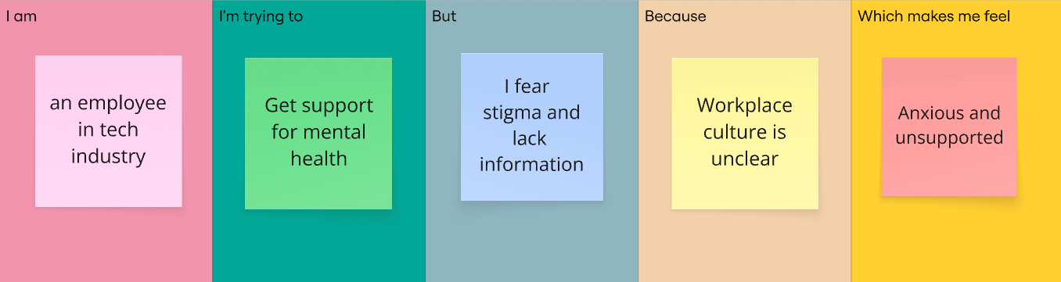

|  |  |  |  |  |  |
| --- | --- | --- | --- | --- | --- |
| **Problem**  **Statement (PS)** | **I am**  **(Customer)** | **I’m trying to** | **But** | **Because** | **Which makes me feel** |
| PS-1 | An employee in tech industry | Get support for mental health | I fear stigma and lack of information | Workplace culture is unclear | Anxious and unsupported |